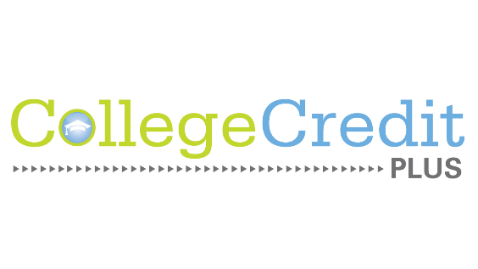
Clear Fork High School

987 St. Rt. 97 E Bellville, OH 44813
Phone (419) 886-2601 Fax (419) 886-4749

Annual Notice for 2022-2023 School Year
This document provides notice of the College Credit Plus program to Clear Fork students in grades 6 through 11 and their parents by February 1. This information will be posted on the school’s website, and written communications including those generally distributed to students, course booklet, student assembly, or information night.
College Credit Plus Costs:
(a) College Credit Plus opportunities have no cost to students, including the free option to attend public institutions of higher education. School districts have the option to seek reimbursement for the tuition the district has paid to the college on behalf of the student if the student receives a non-passing grade or withdraws after the no-fault deadline date.
(b) There is potential cost of participation with a nonpublic/private institution of higher education. Private colleges/universities have the option of charging a minimal fee to students.
(c) Students who are economically disadvantaged who choose to attend a nonpublic institution of higher education cannot be charged a minimum fee.
(d) Clear Fork is not a nonpublic/private school. For students attending nonpublic/private secondary schools, students must apply for state funding to participate and this funding may be limited for students.
(ii) Criteria for student participation, including, but not limited to, the following:
(a) Parents and students must participate in a counseling session prior to participation (which may be included as part of the Information Session).
(b) Important Notice:
"Students must submit a written notice of their intent to participate in the upcoming academic year, by April 1, in accordance with section 3365.03 of the Revised Code, but may submit the written notice of intent to participate as early as February 15. Students desiring to participate in College Credit Plus in the summer are strongly encouraged to submit letters of intent and begin the admissions process starting in February and prior to the April 1 notice of intent deadline in order to improve chances of meeting summer registration timelines."
For students attending nonpublic/private secondary schools, students must submit their intent to participate within the funding application.

Appeal Options when missing the April 1 deadline:
Any student who fails to provide the notification by the required date may not participate in the program during the following school year without the written consent of the principal, or equivalent. If a student seeks consent from the principal after failing to provide notification by the required date (April 1), the principal shall notify the Ohio Department of Education of the student's intent to participate within 10 days of the date on which the student seeks consent. If the principal does not provide written consent, the student may appeal the principal's decision to the district superintendent. Not later than 30 days after the notification of the appeal, the district superintendent or governing entity shall hear the appeal and shall make a decision to either grant or deny that student's participation in the program. The decision of the district superintendent or governing entity shall be final.
There is no appeal for missing the April 1 deadline for students attending nonpublic/private secondary schools or homeschooled students.
(iii) Student participation options:
(a) Secondary schools cannot limit a student's participation in the College Credit Plus program to only the courses offered in that school and students may also participate online or at any other participating institution of higher education, or any combination thereof.
(b) Participating students may be concurrently enrolled in multiple postsecondary institutions and may take postsecondary courses from more than one institution of higher education, concurrently.
(c) List of courses offered at the secondary school through an agreement with an institution of higher education. Available from Guidance Office
(d) Students should review the course catalog of an institution of higher education for a full listing of course offerings by the institution.
(e) At Clear Fork students do have the option to participate in the College Credit Plus program at the high school. Students can also participate online or at an institution of higher education.
(f) Students have the opportunity to participate during the summer term. For any student participating in a summer term that transfers to a new secondary school, the student has the responsibility to notify the institution of higher education and the student's prior and new secondary school of such transfer.
Deadlines:
Feb. 10, 2022 Informational meeting, counseling session
Feb. 24, 2022 Accuplacer Test for all new CCP students @ CFHS
March 15, 2022 ACT Test for all Juniors @ CFHS
April 1, 2022 Letter of Intent form is due
April 1, 2022 Funding application and Intent form are due for nonpublic/private school students
(iv) Emily Marquette or Judy Golden are the designated point of contact for College Credit Plus and will answer questions of students and parents and the community regarding the program's operation and will act as a liaison to the state of Ohio to monitor future changes or amendments to the program.

See https://www.ohiohighered.org/ccp/students-families for funding application deadline, information, and links.
See Ohio Revised Code 3365.03 for additional details.
The secondary school should indicate if the school does or does not offer college courses within the school building.

